CSA09 – ASSIGNMENT 1
DESIGN, IMPLEMENT AND VALIDATE AN
OBJECT-ORIENTED MODEL FOR A
CAMPUS SMART-PARKING SYSTEM
A Technical Report submitted in partial fulfilment of
CO1 – Java Fundamentals and Object-Oriented Programming
Student Name: Prathiksha SN
Register Number: 192565090
Assignment Code: CSA09 – Assignment 1
Programming Language: Java
College / Institution: SIMATS Engineering
Department: B.tech CSE with CS
GitHub Repository: https://github.com/prathikshasaravanan/CSA0913-192565090-assignment1

DECLARATION
I, Anjali Oviya (Register Number: 192521452), declare that this report and the associated Java assignment work are submitted for the course outcome CO1. The implementation evidence and explanations are based on the supplied project source and verification record. I will review the work, execute the programs independently and ensure that the submitted repository and screenshots represent my own verified work.
Student Signature: Prathiksha SN Date: 12. 11.2026

ABSTRACT
This report analyses, implements and evaluates a Java 21 object-oriented model for a campus smart-parking system. The model represents vehicles, users, parking slots and tickets as objects; organises floors using a jagged array; and stores active tickets in a HashMap keyed by normalized registration number. The implementation demonstrates constructors, static ticket numbering, inheritance, overriding, polymorphism, an abstract Vehicle class, a Chargeable interface, packages and encapsulation. The improved project adds e-bike flat-fee and delivery-van time-dependent pricing, visitor one-day pass support, charging-slot preference and defensive validation. The supplied verification record reports successful compilation and execution of the main application, Task 3 and Task 8 programs, together with 21 passing regression checks. The report distinguishes those recorded checks from screenshots and local execution evidence that the student must still capture. The current main demonstration configures three floors with capacities {3, 2, 4}; a five-floor run is therefore identified as outstanding verification rather than claimed as completed.

TABLE OF CONTENTS
[Update the automatic table of contents in Microsoft Word: References → Table of Contents → Update Table. The chapter and section headings use Word heading styles.]
- Chapter 1 – Introduction
- Chapter 2 – Task 1: Problem Analysis and Object Identification
- Chapter 3 – Task 2: Data Representation
- Chapter 4 – Task 3: Control Logic and Pseudocode
- Chapter 5 – Task 4: Classes, Objects and Constructors
- Chapter 6 – Task 5: Static Members and Object Lifecycle
- Chapter 7 – Task 6: Inheritance Hierarchy
- Chapter 8 – Task 7: Method Overriding
- Chapter 9 – Task 8: Polymorphism
- Chapter 10 – Task 9: Abstraction
- Chapter 11 – Task 10: Packages and Encapsulation
- Chapter 12 – Task 11: Implementation, Testing and Defence
- Chapter 13 – Task 12: Day-4 Design Challenge
- Chapter 14 – Conclusion
- References

LIST OF FIGURES
- Figure 1. Overall system architecture
- Figure 2. Core model class diagram
- Figure 3. Vehicle inheritance and capability hierarchy
- Figure 4. Java package structure
- Figure 5. Vehicle entry activity flow
- Figure 6. Vehicle exit activity flow
- Figure 7. Task 12 adapted architecture

LIST OF TABLES
- Table 1. Candidate classes and responsibilities
- Table 2. Parallel arrays versus objects
- Table 3. Data representation alternatives
- Table 4. Control and complexity comparison
- Table 5. Constructor strategies
- Table 6. Static counter alternatives
- Table 7. Inheritance versus composition
- Table 8. Overriding versus switch-based pricing
- Table 9. Abstraction alternatives
- Table 10. Encapsulation comparison
- Table 11. Regression test evidence
- Table 12. Task 12 change-impact analysis

CHAPTER 1 – INTRODUCTION

1.1 Background and system context
The assignment scenario describes a university campus with multiple parking floors and fixed slot capacities. Students, staff and visitors use the facility. Vehicles include two-wheelers, cars and electric vehicles; EVs may use charging-enabled slots and incur a separate charging fee. On entry, the system must allocate a suitable free slot, issue a unique ticket and record entry time. On exit, it must release the slot and calculate the fee. Valid student and staff monthly passes waive parking charges; visitors normally pay unless they hold the one-day pass introduced in the design challenge.

1.2 Problem statement
A manual or loosely structured parking process can lead to duplicate occupancy, inaccurate duration billing, lost ticket information and difficulty extending the rules as new vehicle categories or floor layouts are introduced. The system must represent the facility and its operations reliably while keeping vehicle-specific pricing extensible.

1.3 Objectives
- Model vehicles, users, slots and tickets as Java objects with clear responsibilities.
- Allocate and release slots safely across floors with potentially different capacities.
- Generate unique ticket numbers and retain active tickets for exit processing.
- Calculate parking and EV charging fees according to explicit implementation rules.
- Apply monthly and one-day pass eligibility.
- Demonstrate core CO1 object-oriented concepts and validate boundary and invalid cases.

1.4 Scope
The supplied project is a Java console demonstration with a model package, a service package, an application entry point and a dependency-free regression test runner. It does not include a graphical user interface, database persistence, payment gateway or networked multi-user deployment. The current main demonstration uses a three-floor configuration; support for arbitrary floor counts is present in the jagged-array constructor, but the specified five-floor deployment has not been demonstrated in the included main output.

1.5 Functional requirements
- Accept vehicle, user and entry-time information.
- Reject missing required references and duplicate active registrations.
- Find a suitable free slot and prefer charging-enabled slots for ElectricCar.
- Create a ticket with a unique sequential identifier.
- Find active tickets by normalized registration number.
- Calculate vehicle parking fees and add EV charging fees where applicable.
- Waive parking fee for qualifying passes.
- Release the occupied slot and remove the active ticket after a valid exit.
- Expose floor count, total slots, available slots and active vehicle count.

1.6 Non-functional requirements
- Correctness: prevent double occupancy and invalid state transitions.
- Maintainability: isolate model classes and facility operations in packages.
- Extensibility: specialize pricing through vehicle subclasses and capabilities through interfaces.
- Input robustness: validate null, blank, negative, non-finite and invalid time values.
- Efficiency: use a HashMap for average constant-time active-ticket lookup.
- Portability: compile using Java 21 without external libraries.

1.7 Assumptions and constraints
The README explicitly labels its tariffs as sample teaching assumptions, not official campus prices. Two-wheelers cost Rs 10 per started hour; cars and electric cars cost Rs 30 per started hour; EV charging costs Rs 12 per kWh; e-bikes cost a flat Rs 20 per visit; delivery vans use twice the car rate for billable hours whose start time is from 09:00 inclusive to 17:00 exclusive. Every started hour is charged in full, while a zero-minute stay costs zero. The system uses local date-time values without a time-zone model. The current demonstration has 3 floors with capacities {3,2,4}.

1.8 Requirements traceability note
The official brief specifies the task topics and examples but leaves some detailed tariff values open. The implementation README supplies the assumptions above. The report uses those values only when describing the code and identifies them as implementation assumptions.

CHAPTER 2 – TASK 1 – PROBLEM ANALYSIS AND OBJECT IDENTIFICATION

2.1 Inputs and outputs
Inputs | Outputs
Vehicle registration and category; user identity/type/pass status; entry timestamp; exit timestamp; EV energy in kWh; floor capacities and charging-slot positions. | Ticket number; allocated floor and slot; parking fee; charging fee; total fee; availability and occupancy counts; validation errors when an operation is invalid.

2.2 Candidate class identification
Nouns in the scenario suggest domain objects; verbs suggest operations. The implementation contains Vehicle, Car, TwoWheeler, ElectricCar, EBike, DeliveryVan, ParkingUser, ParkingSlot, ParkingTicket and ParkingFacility. The implementation also uses VehicleCategory and UserType enums and the Chargeable interface.
Candidate class | Attributes / state | Responsibilities / justification
Vehicle (abstract) | registrationNumber; category | Common identity, normalization, equality and abstract parking-fee behaviour.
Car | Inherited vehicle state; rate constant | Car hourly pricing; parent for ElectricCar.
TwoWheeler | Inherited vehicle state; rate constant | Two-wheeler-specific pricing.
ElectricCar | Inherited car state; charging rate | EV category and Chargeable capability.
EBike | Inherited vehicle state; flat-fee constant | Represents the new e-bike pricing category.
DeliveryVan | Inherited vehicle state; car/day rates | Implements time-sensitive delivery-van pricing.
ParkingUser | userId, name, userType, pass flags | Determines whether a user qualifies for a parking-fee waiver.
ParkingSlot | floor, slot, chargingEnabled, vehicle | Maintains occupancy and charging-slot capability.
ParkingTicket | ticketNumber, vehicle, user, slot, entryTime | Captures the active parking transaction.
ParkingFacility | ParkingSlot[][] and active-ticket Map | Coordinates entry, slot search, exit, fee and occupancy.

2.3 Business rules
- A slot may contain at most one vehicle; ParkingSlot.park rejects an occupied slot.
- A slot can be released only when occupied; release rejects an already free slot.
- A registration number is normalized to trimmed uppercase form and only one active ticket per registration is allowed.
- Ticket identifiers are generated from one shared AtomicLong sequence and incremented from 1000.
- A valid student/staff monthly pass or visitor one-day pass waives the parking fee.
- EVs prefer charging-enabled slots; if none is available, the facility may allocate a non-charging slot or any remaining free slot according to findSlot logic.
- Invalid exit input must not release the slot or remove the ticket; regression tests verify selected invalid cases.

2.4 Assumptions
- Registration numbers are treated case-insensitively after trimming and uppercasing.
- Parking duration is measured in whole minutes using Duration.between; each started hour is billed as a full hour.
- The EV charging fee is added separately when the vehicle implements Chargeable.
- The pass waiver applies to the parking fee; the code adds charging fee separately after the waiver decision.
- No persistent database or concurrency-safe external ticket store is included. Entry and exit methods are synchronized within one ParkingFacility object.

2.5 Parallel arrays alternative
String[] regNo = new String[n];
String[] type = new String[n];
LocalDateTime[] entryTime = new LocalDateTime[n];
The same vehicle record would occupy the same index across all arrays. A loop would search regNo[i] and then use i to read type[i] and entryTime[i].
Criterion | Vehicle object design | Parallel arrays
Find registration | Linear scan O(n) if a list/array is used; current active registry uses HashMap average O(1). | Linear scan O(n) over regNo[].
Add attribute | Add a field and related methods to the class; one cohesive type. | Add another parallel array and keep every index synchronized.
Maintainability | Encapsulates state and behaviour; easier to extend with subclasses. | Index misalignment risk; logic and data are separated.
Space per vehicle | O(1) fields per object; total O(n). | O(1) cells per attribute; total O(n) for fixed attribute count.

Conclusion: parallel arrays can store simple records, but object modelling better captures behaviour and invariants. For this project the actual active-ticket lookup goes beyond a linear object array and uses HashMap<String, ParkingTicket>.

CHAPTER 3 – TASK 2 – DATA REPRESENTATION

3.1 Java data types in the implementation
Data | Implementation type | Reason
Registration number | String | Alphanumeric identifier; normalized to uppercase.
Vehicle category / user type | enum | Restricts values to defined categories.
Floor and slot indexes | int | Non-negative integral positions.
Entry / exit time | LocalDateTime | Represents date and wall-clock time.
Duration | long minutes / billable hours | Duration may exceed int range; integer billing arithmetic.
Parking fee / charging fee | double | Supports decimal currency and energy multiplication.
Ticket number | long via AtomicLong | Sequential identifier with larger range.
Active tickets | HashMap<String, ParkingTicket> | Registration-keyed lookup.

3.2 Floor and slot representation
ParkingFacility declares ParkingSlot[][] floors. The outer array has one element per floor; each inner array is created using that floor's configured capacity. This is a jagged array and supports different slot counts per floor. The current app constructs new int[]{3, 2, 4}, so it demonstrates three floors, not the five-floor challenge configuration.

3.3 Integer division and precision
If minutes are converted using minutes / 60 with integer operands, 61 / 60 evaluates to 1, which undercharges a started-hour tariff. The implementation avoids this by ceiling division: (minutes + 59) / 60. Thus 61 minutes becomes 2 billable hours. For a car at Rs 30/hour, the fee is Rs 60. Zero minutes remains zero.
long billableHours = (minutes + 59) / 60;
double fee = billableHours * RATE_PER_HOUR;
The model uses double for monetary values. For production accounting, BigDecimal with an explicit currency rounding policy would be safer than binary floating-point. The supplied code and tests use double comparisons for these fixed simple values.

3.4 Input reading
ParkingApp imports Scanner but the supplied demonstration uses fixed LocalDateTime values and does not read interactive console input. For an interactive version, Scanner can read registration, category, timestamps and kWh. Validate each token and catch parsing exceptions; command-line arguments are appropriate for scripted runs but less convenient for guided data entry.

3.5 Representation alternatives and complexity
Representation | Locate slot / scan | Space | Different floor sizes
Jagged array ParkingSlot[][] | O(F×Smax) worst case scan | O(total slots) | Directly supports each floor's independent length.
Flat 1-D array | O(F×S) scan; arithmetic index O(1) only when uniform slots-per-floor | O(F×S) | Requires prefix offsets or mapping when capacities differ.
ArrayList<String[]> | O(F×S) scan by iteration; indexed access O(1) per row | O(total slots) plus list overhead | Supports variable row lengths.

For the current array, let F be floor count and S be the maximum slots on any floor; actual total slots is T = sum of floor capacities. A full scan is O(T), and storage is O(T). A flat index formula floor × slotsPerFloor + slot assumes a uniform capacity; with unequal capacities, prefix sums or a per-floor mapping is required.

CHAPTER 4 – TASK 3 – CONTROL LOGIC AND PSEUDOCODE

4.1 Allocation pseudocode
ALGORITHM Allocate(vehicleNo)
IF vehicleNo is null or blank THEN reject input
FOR each floor f from 0 to floorCount - 1
FOR each slot s in floor f
IF slots[f][s] is empty THEN
slots[f][s] ← vehicleNo
RETURN (f, s)
END IF
END FOR
END FOR
RETURN null // facility is full

4.2 Release pseudocode
ALGORITHM Release(floor, slot)
IF floor is outside valid floor range THEN RETURN false
IF slot is outside the selected floor's range THEN RETURN false
IF selected slot is already empty THEN RETURN false
Set selected slot to empty
RETURN true

4.3 Fee calculation pseudocode
ALGORITHM CalculateFee(entry, exit, rate)
IF entry or exit is null OR exit < entry THEN reject interval
minutes ← whole minutes between entry and exit
IF minutes = 0 THEN RETURN 0
hours ← (minutes + 59) DIV 60
RETURN hours × rate

4.4 Control structures
- for loops traverse floors and slots; nested loops implement a two-dimensional scan.
- if–else chooses between valid/invalid input, free/occupied slots and pass/no-pass billing.
- break exits a loop early when a match is found; the current Task 3 allocation uses return to leave the method immediately.
- continue can skip unsuitable slots, such as occupied or non-charging slots, without nesting further conditions.
- return sends a result to the caller and stops the current method.
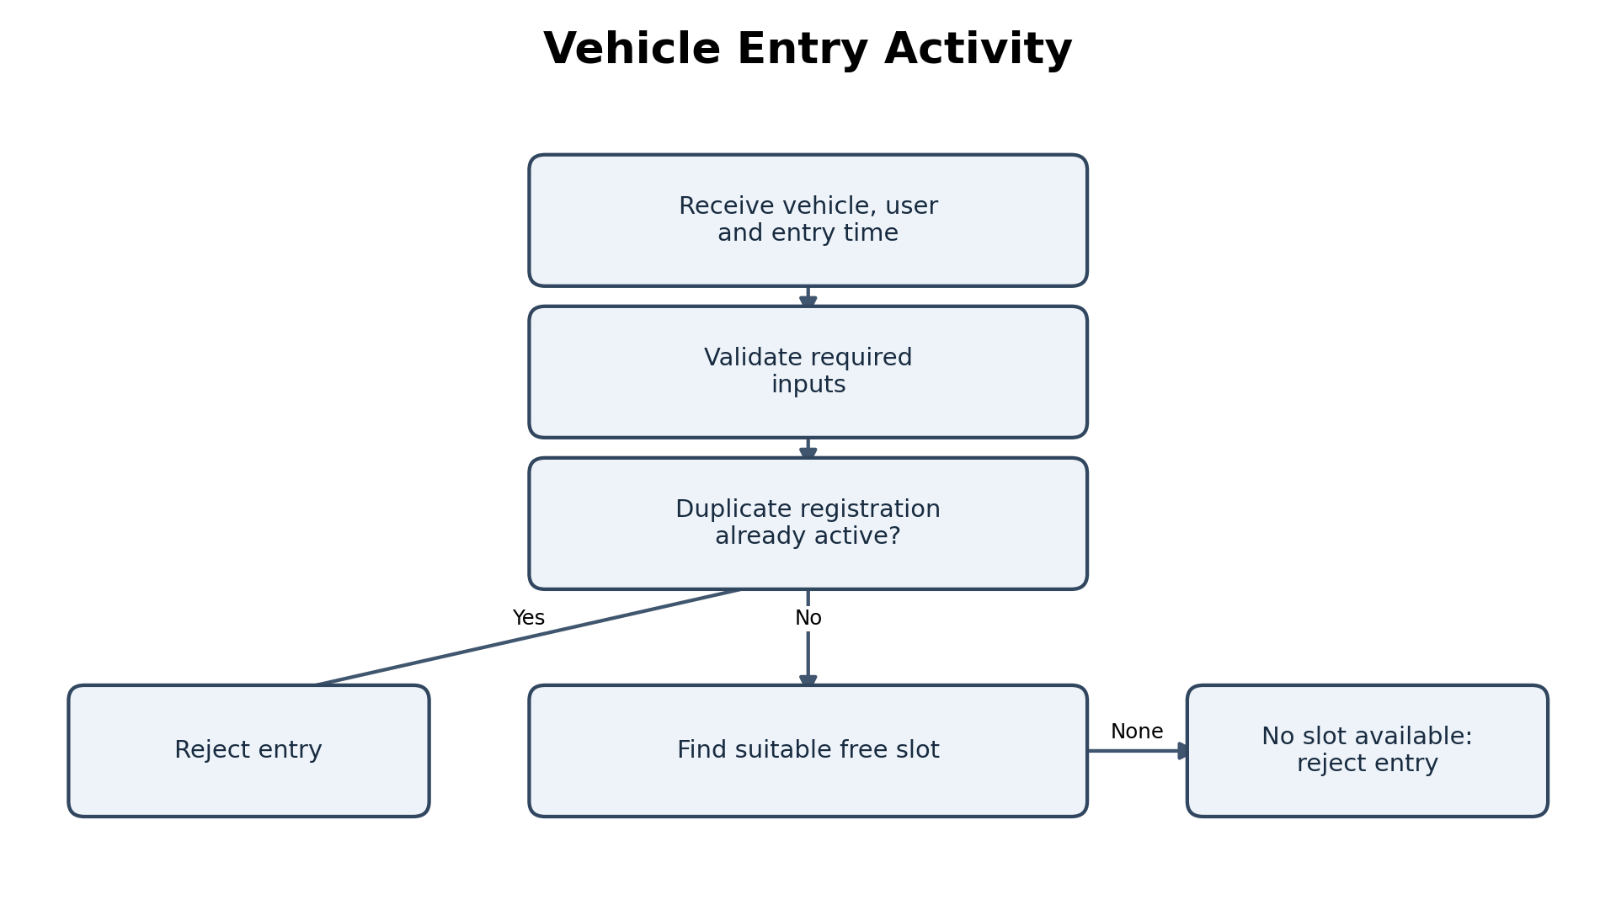
Figure 5. Vehicle entry activity flow (conceptual workflow based on ParkingFacility).
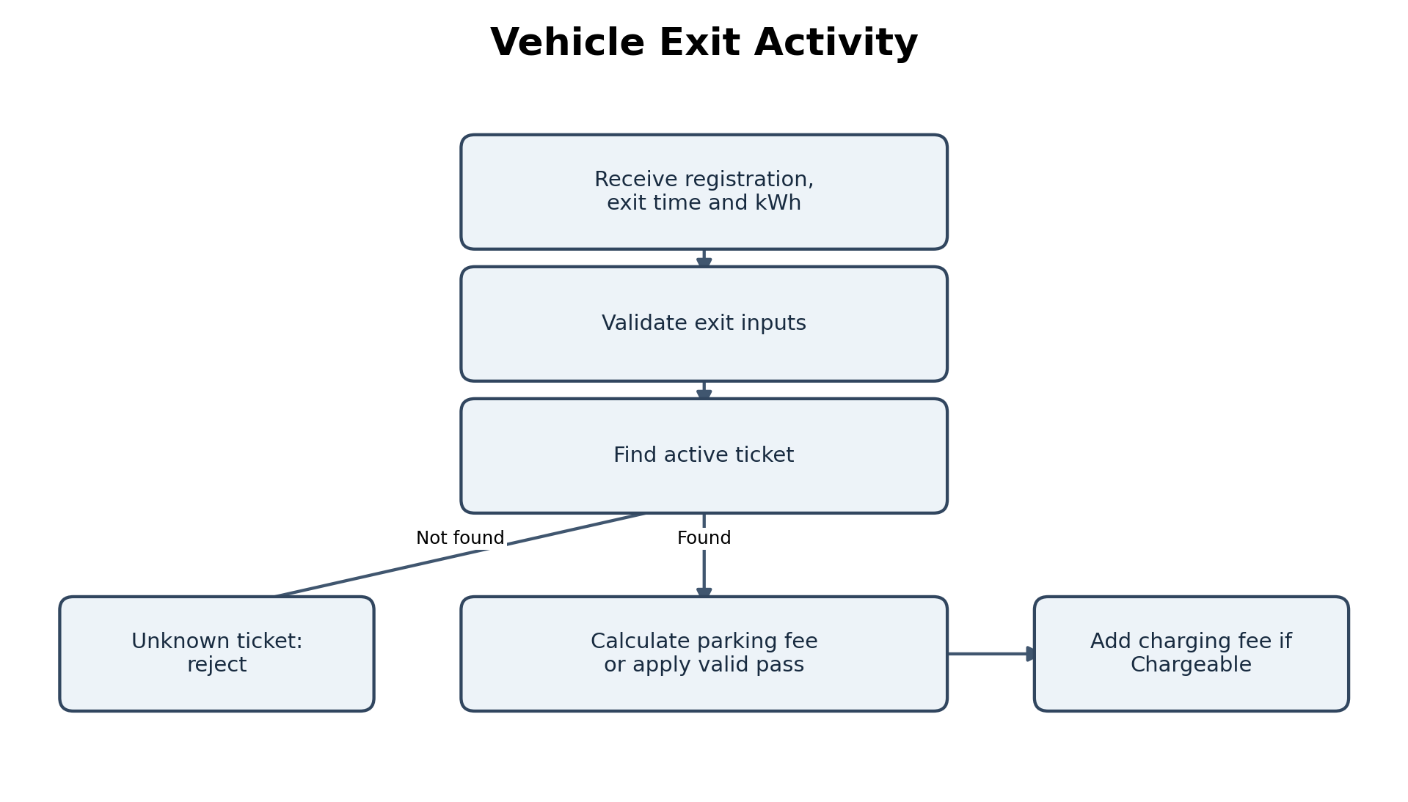
Figure 6. Vehicle exit activity flow (conceptual workflow based on ParkingFacility).

4.5 Actual Task 03 output
[0, 0]
[0, 1]
[1, 0]
null
true false false
[0, 1]
- First three allocations fill floor 0 slot 0, floor 0 slot 1, and floor 1 slot 0.
- The fourth allocation returns null because all three slots are occupied.
- The release expression returns true for the first valid release, false for the same slot when released again, and false for invalid floor 5.
- The final allocation reuses the freed position [0, 1].

4.6 Scanning versus free-slot stack
Approach | Allocate | Release | Extra space
Current scan | O(T) worst case; stops at first free slot | O(1) after coordinate validation | O(T) for slots; no separate free list
Per-floor free-slot stacks + free counts | O(1) amortized pop from a selected non-empty floor stack; choosing a floor can be O(F) unless an index structure is added | O(1) push and count update | O(T) stored free coordinates plus O(F) counters

The stack approach improves repeated allocation when a non-empty floor can be selected efficiently, but requires synchronization between stack entries and slot occupancy. If the system must prefer charging positions, separate stacks or priority selection are needed.

CHAPTER 5 – TASK 4 – CLASSES, OBJECTS AND CONSTRUCTORS

5.1 Classes, objects, fields and methods
A class defines a type and its operations; an object is a runtime instance with its own state. Vehicle stores registration and category. ParkingSlot stores floor, slot, charging capability and current vehicle. ParkingTicket stores the transaction references and entry timestamp. ParkingFacility coordinates the operations.

5.2 Constructors and this / super
The model uses parameterised constructors to establish valid state. Vehicle validates and normalizes registration before storing it. Car has a public constructor that delegates to a protected constructor using this(regNo, VehicleCategory.CAR); ElectricCar calls the protected Car constructor with ELECTRIC_CAR. This constructor chaining avoids duplicating base initialization. Subclasses call super(...) so the superclass establishes common vehicle state.
public Car(String regNo) { this(regNo, VehicleCategory.CAR); }
protected Car(String regNo, VehicleCategory category) { super(regNo, category); }
public ElectricCar(String regNo) { super(regNo, VehicleCategory.ELECTRIC_CAR); }

5.3 Default, overloaded and copy constructors
The supplied core model primarily uses parameterised constructors; it does not expose a public no-argument default constructor for Vehicle or ParkingTicket. Constructor overloading is demonstrated by ParkingFacility: one constructor accepts floor capacities and charging positions, while another accepts only capacities and delegates with an empty set. No copy constructor is implemented. Re-issuing a duplicate ticket should normally be a new transaction with a new unique identifier, not a shallow copy of the old ticket.

5.4 Memory model
A local reference variable is typically stored in a stack frame, while objects and arrays are allocated on the heap. A ParkingTicket reference points to a ticket object, which in turn refers to Vehicle, ParkingUser and ParkingSlot objects. Java passes object references by value: a method receives a copy of the reference value and can mutate the referenced object, but reassigning its local parameter does not reassign the caller's variable.

5.5 Object creation strategy comparison
Strategy | Validity guarantee | Cost for n tickets
Parameterised constructor | Can validate all required values before construction completes; preferred here. | O(n) object construction overall; O(n) ticket storage.
Default + setters | Object may temporarily exist in incomplete/invalid state; each setter must validate. | O(n) object creations plus O(n) setter calls; asymptotically O(n).
Static factory | Can validate, name creation intent and choose implementation; can control caching if needed. | O(n) for n new tickets; same asymptotic storage O(n).

All three strategies have O(1) work per ticket under fixed validation and O(n) total time and storage for n ticket objects. Their key difference is state safety and API clarity, not asymptotic complexity.

CHAPTER 6 – TASK 5 – STATIC MEMBERS AND OBJECT LIFECYCLE

6.1 Static ticket number
ParkingTicket declares private static final AtomicLong NEXT_ID = new AtomicLong(1000). Each ticket constructor calls incrementAndGet(), so the sequence is shared across all ParkingTicket instances in the JVM and begins at 1001 in a fresh process. AtomicLong makes the increment operation atomic across threads.

6.2 Why an instance counter differs
If each ParkingFacility owned an instance counter, two facilities could independently issue the same ticket number unless a shared namespace or facility prefix were added. A static counter gives one process-wide sequence. For k facilities, one shared counter uses O(1) counter storage; k instance counters use O(k). Storing n ticket objects still uses O(n) space.

6.3 Static methods and blocks
A static method is suitable for operations that do not depend on a particular object. The project does not define a custom static utility method or static initialization block. The static AtomicLong field is initialized when the class is initialized.

6.4 Ticket lifecycle and garbage collection
On entry, ParkingFacility creates a ParkingTicket and stores it in activeTickets. On successful exit, it releases the slot and removes the map entry. Once no reachable object retains the ticket, it becomes eligible for garbage collection; collection timing is controlled by the JVM and is not immediate or guaranteed at the moment of removal. The ticket references its vehicle, user and slot, so those objects may also remain reachable through other references.

6.5 Object passing and return
vehicleEntry accepts Vehicle, ParkingUser and LocalDateTime references and returns a ParkingTicket reference. vehicleExit accepts a registration string, exit time and kWh, then returns a primitive double. The ticket is returned to the caller while also being registered in the active-ticket map.

CHAPTER 7 – TASK 6 – INHERITANCE HIERARCHY

7.1 Actual hierarchy
The source defines abstract Vehicle as the base class. TwoWheeler, Car, EBike and DeliveryVan extend Vehicle. ElectricCar extends Car and implements Chargeable. This is hierarchical inheritance from Vehicle and a multilevel path Vehicle → Car → ElectricCar. Java classes support single inheritance; the capability interface is implemented separately.
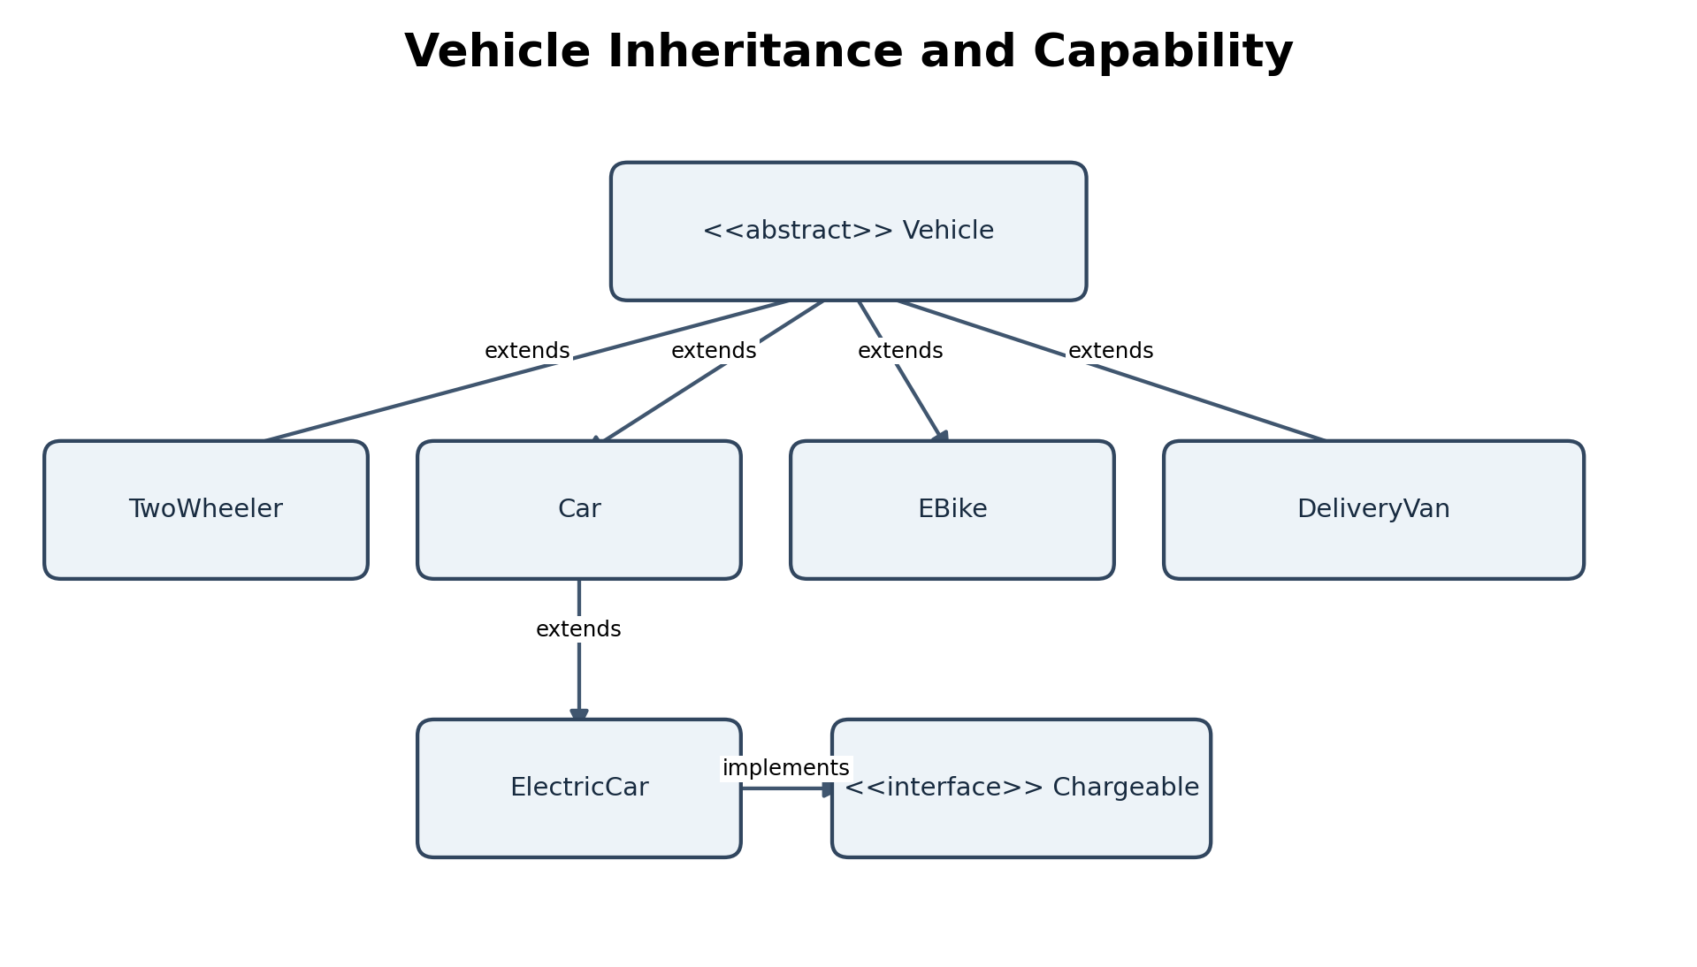
Figure 3. Vehicle inheritance and Chargeable capability. Arrows indicate extension or interface implementation.

7.2 Inherited and specialized state
- Vehicle owns normalized registrationNumber and VehicleCategory, getters, common fee contract, billableHours validation, toString, equals and hashCode.
- Car supplies the car hourly rate and can serve as a parent for ElectricCar.
- ElectricCar preserves the ELECTRIC_CAR category and adds chargingFee through Chargeable.
- TwoWheeler supplies its own hourly rate; EBike supplies a flat fee; DeliveryVan applies time-dependent pricing.

7.3 Constructor execution trace: ElectricCar
- new ElectricCar("TN...") begins subclass construction.
- ElectricCar invokes super(regNo, VehicleCategory.ELECTRIC_CAR) through Car's protected constructor.
- Car invokes Vehicle(regNo, category).
- Vehicle validates, trims and uppercases the registration and stores category.
- Control returns through Car to ElectricCar; the ElectricCar object is fully initialized.

7.4 Inheritance versus composition
Criterion | Inheritance | Composition alternative
Representation | Car is-a Vehicle; subclass overrides fee behaviour. | Vehicle has-a VehicleType or PricingStrategy object.
Add a category | Add a subclass and override fee method. | Add a strategy/type object; vehicle class can remain unchanged.
Fee call | Virtual method dispatch, effectively O(1) selection plus calculation. | Strategy call also O(1) dispatch plus calculation.
Per-vehicle space | Subclass object includes inherited state and subclass-specific data. | Vehicle holds an additional strategy reference; strategy may be shared.

Inheritance is readable for stable categories with genuine IS-A relationships. Composition is more flexible when pricing rules change independently of physical vehicle identity or when many combinations of capabilities emerge.

CHAPTER 8 – TASK 7 – METHOD OVERRIDING

8.1 Overridden behaviour
Vehicle declares abstract calculateParkingFee(entry, exit). Car, TwoWheeler, EBike and DeliveryVan provide concrete implementations. ElectricCar inherits Car's parking fee calculation and adds chargingFee through Chargeable. Each override is marked @Override, allowing the compiler to detect signature mistakes.

8.2 Rules and Object methods
- An overriding method must match the inherited method signature and use a compatible return type; it cannot reduce access visibility.
- Vehicle.toString() returns a concise class-name and registration representation.
- Vehicle.equals() treats two Vehicle instances with the same normalized registration as equal, even if their runtime subclasses differ.
- hashCode() uses the same registration value, satisfying the equals/hashCode contract.
- The code uses final constants for fixed tariff values; it does not declare final vehicle classes or final pricing methods.
The FeeDemo example's equality check returns true for Car("TN02B2") and ElectricCar("TN02B2") because equality is based only on registration. This is an explicit design choice; if vehicle category must distinguish identity, equals should include category or use a different identity key.

8.3 Overriding versus switch
Criterion | Overriding | Single switch-based method
New category | Add subclass; existing vehicle pricing methods can remain unchanged. | Modify central switch and often category enum / tests.
Dispatch cost | O(1) virtual dispatch, then fee calculation. | O(1) for switch over finite enum; up to O(k) if implemented as sequential checks.
Maintainability | Pricing logic distributed by behaviour owner. | Centralized but may grow into a large conditional method.
Risk | Subclass consistency and inheritance design required. | Central switch can be forgotten when category is added.

For k categories, dispatch is constant time in the usual implementation model; total fee calculation complexity depends on the pricing algorithm. DeliveryVan loops over billable hours, so its calculation is O(H) in the number of billable hours.

CHAPTER 9 – TASK 8 – POLYMORPHISM

9.1 Compile-time and runtime polymorphism
Compile-time polymorphism is method overloading: methods share a name but differ in parameter lists, and the compiler selects the overload from the declared argument types. Runtime polymorphism is method overriding: a Vehicle reference can refer to a TwoWheeler, Car or ElectricCar, and the actual object's overridden implementation is selected at runtime.

9.2 Upcasting and dynamic dispatch
Vehicle[] parked = { new TwoWheeler("TN01A1"), new Car("TN02B2"),
new ElectricCar("TN03C3") };
for (Vehicle v : parked) {
double fee = v.calculateFee(130); // FeeDemo example
}
In the standalone FeeDemo, the declared reference type is Vehicle and the runtime object types vary. The implementation's separate project model uses calculateParkingFee(LocalDateTime, LocalDateTime) rather than the integer-minute overload shown in the standalone task.

9.3 Actual Task 08 output
TwoWheeler TN01A1 -> Rs 30.0
Car TN02B2 -> Rs 90.0
ElectricCar TN03C3 -> Rs 210.0
true
- TwoWheeler: 130 minutes rounds up to 3 hours; 3 × Rs 10 = Rs 30.
- Car: 3 × Rs 30 = Rs 90.
- ElectricCar: 3 × Rs 30 = Rs 90 parking plus 10 × Rs 12 = Rs 120 charging; total Rs 210.
- true: the two objects have the same registration number, and FeeDemo.equals compares registration only.

9.4 Dynamic dispatch trace
Stage | Value
Declared reference type | Vehicle
Actual object type | ElectricCar
Invocation | v.calculateFee(130)
Selected implementation | Inherited Vehicle.calculateFee calls ratePerHour(); runtime override in Car returns 30.
Charging capability | instanceof Chargeable succeeds; ElectricCar.chargingFee(10) adds Rs 120.

The standalone FeeDemo has an overloaded conceptual design request, but its supplied executable code only implements calculateFee(int minutes). The main project uses a different LocalDateTime fee method. Do not claim a second overload exists unless it is added and executed.

CHAPTER 10 – TASK 9 – ABSTRACTION

10.1 Abstract Vehicle
Vehicle is abstract because a generic vehicle has shared registration/category state but no single universal parking tariff. Its abstract calculateParkingFee method requires each concrete category to supply its own pricing behaviour. The protected constructor initializes shared state and prevents direct construction of the abstract type.

10.2 Chargeable interface
Chargeable expresses a capability rather than an identity. ElectricCar implements chargingFee(kWh), while ordinary vehicles do not need to implement that method. ParkingFacility checks instanceof Chargeable and adds the charging fee when supported.

10.3 Alternative reversal
If Vehicle became an interface, it could declare abstract/default methods but could not hold ordinary per-object instance fields initialized by a constructor. A separate concrete base class or composition object would be needed for registration/category state. If Chargeable became an abstract class, a class already extending Vehicle could not also extend Chargeable because Java allows only one superclass. Interface-based capabilities allow a class to implement multiple independent contracts.
Aspect | Current design | Reversed design
Shared state and constructor | Abstract Vehicle class supports fields and constructor. | Vehicle interface cannot provide instance fields or constructors.
Capability composition | Chargeable interface can be implemented alongside class inheritance. | Chargeable abstract class consumes the single superclass slot.
Method call cost | Virtual/interface dispatch, O(1) model. | Same asymptotic dispatch cost.
Object space | Common state stored in Vehicle object fields. | State must move into implementation/composition; extra references may be needed.

The current abstract-class-plus-interface design is appropriate because vehicle identity has shared state while charging is an optional capability.

CHAPTER 11 – TASK 10 – PACKAGES AND ENCAPSULATION

11.1 Package structure
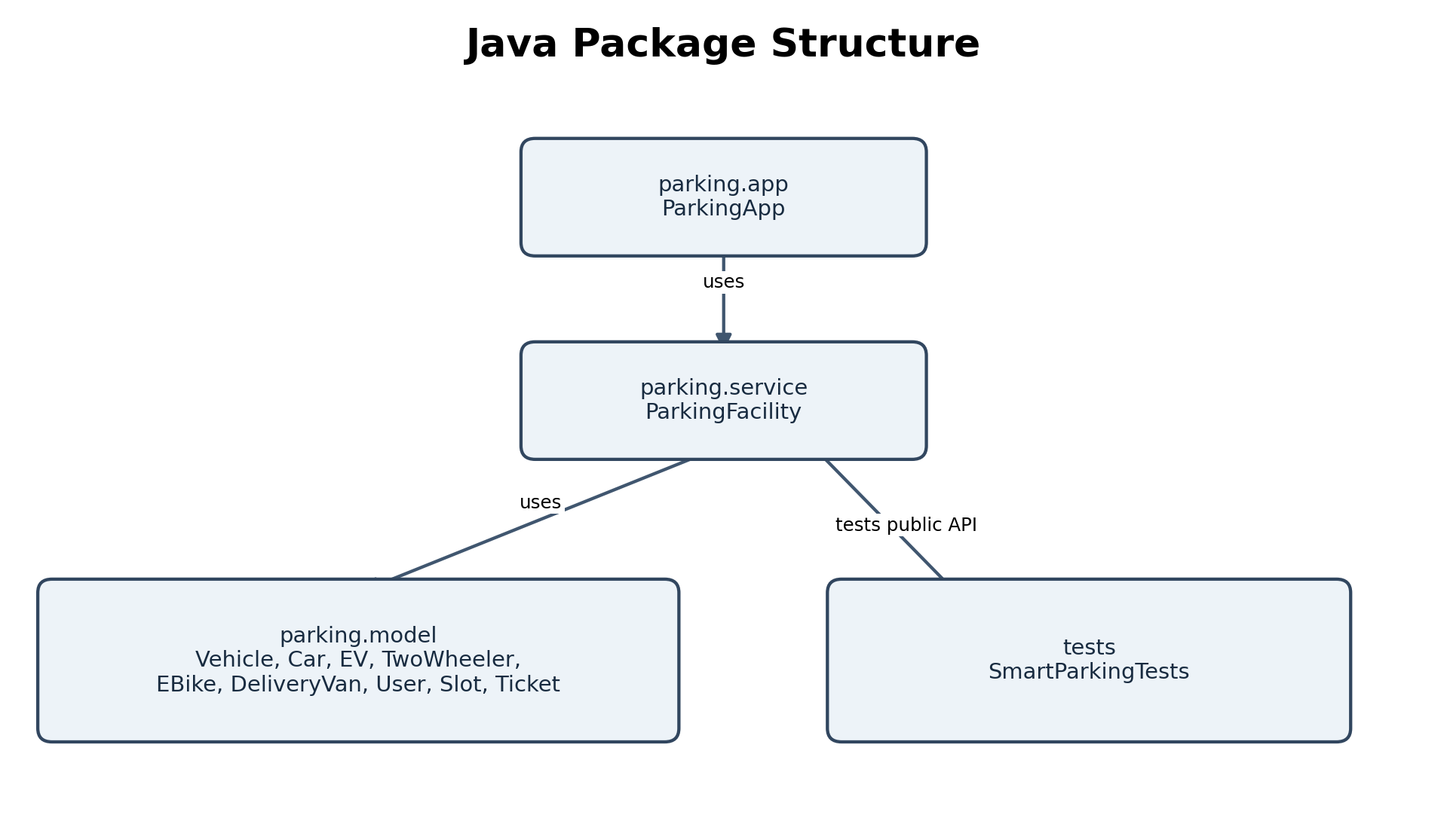
Figure 4. Package diagram for the supplied Java project.
- parking.app contains ParkingApp, the console demonstration.
- parking.service contains ParkingFacility, which coordinates the operations.
- parking.model contains vehicle types, enums, ParkingUser, ParkingSlot, ParkingTicket and Chargeable.
- The test runner is stored under tests and imports the public model/service API.

11.2 Access modifiers
Modifier | Meaning | Observed use
private | Accessible only within declaring class. | Vehicle fields, ticket fields, slot state, activeTickets.
public | Accessible from other packages/classes. | Public constructors and public operations/getters.
protected | Package-level plus subclasses. | Vehicle constructor and billableHours; Car specialization constructor.
default (package-private) | Accessible within same package only. | Standalone FeeDemo classes and constructors not declared public.

11.3 Encapsulation and validation
The model fields are private and final where appropriate. Getters expose controlled read access. Constructors reject blank registration numbers, null categories, null user types, invalid coordinates and missing ticket references. ParkingSlot.park/release enforce occupancy invariants. ParkingFacility validates entry and exit arguments before mutating ticket/slot state.

11.4 Wrapper types, autoboxing and == risk
The core model primarily uses primitives for indexes and double fee values. Collections such as HashMap use reference types for keys and values; Java boxes primitive values when wrapper types are required. Wrapper equality should generally use equals(), not ==, because == compares object identity for reference objects and may appear to work only for cached values such as some small Integers.

11.5 Public fields alternative
Design | Effect
Private fields + validated methods | One central place enforces invariants; callers cannot directly assign invalid state.
Public fields + caller validation | Every caller must repeat checks; one missed check can corrupt state. Validation execution is O(1) per update but duplicated across potentially many call sites.

CHAPTER 12 – TASK 11 – IMPLEMENTATION, TESTING AND DEFENCE

12.1 Architecture and workflow
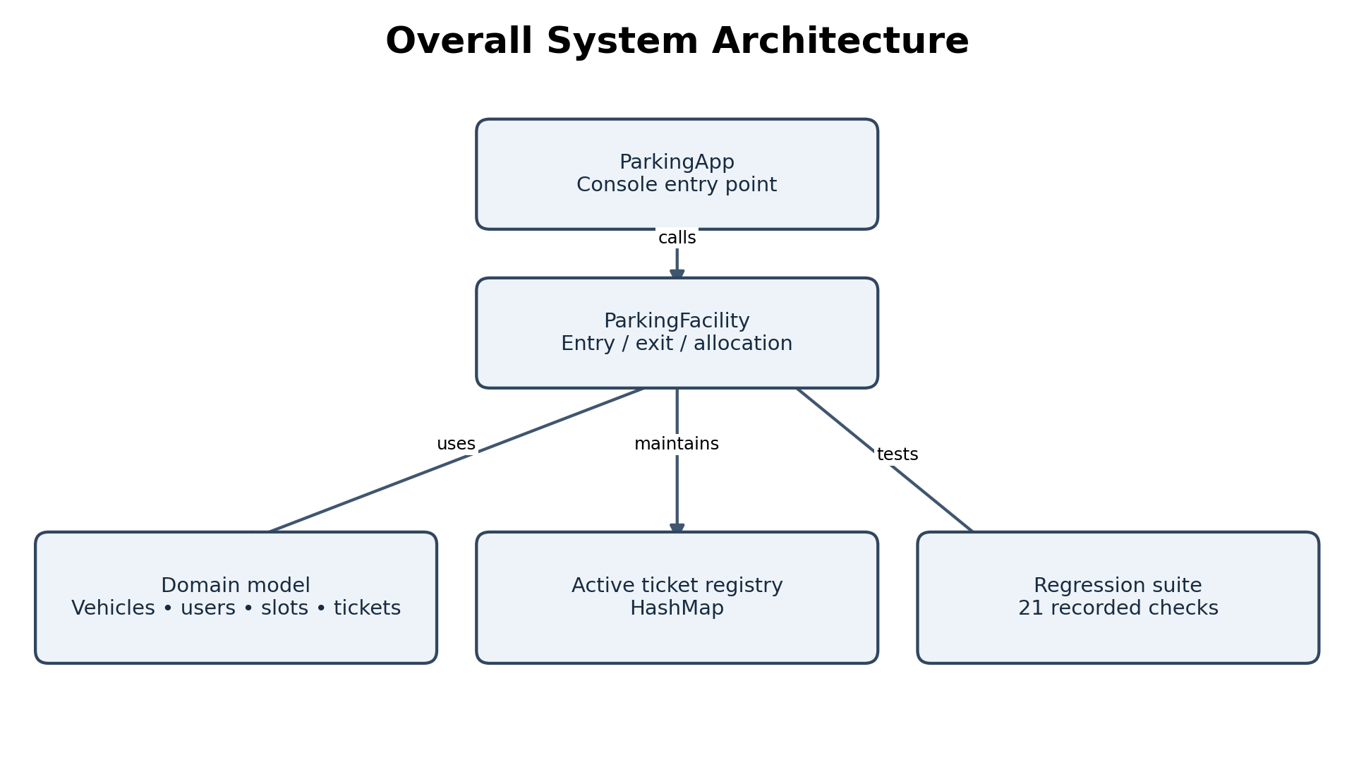
Figure 1. Overall system architecture.
ParkingApp creates a ParkingFacility, ParkingUser and ElectricCar, then demonstrates entry, ticket issuance, exit, fee calculation and available-slot reporting. ParkingFacility owns the jagged array of ParkingSlot objects and a HashMap of active tickets. Model classes represent state and vehicle-specific behaviour. SmartParkingTests exercises the public API.

12.2 Vehicle entry workflow
- Validate vehicle, user and entry timestamp references.
- Reject a duplicate active registration.
- Search for a suitable slot; ElectricCar requests charging preference.
- Park the vehicle in the selected slot.
- Construct a ParkingTicket with a unique ID and store it in activeTickets.
- Return the ticket to the caller.

12.3 Vehicle exit workflow
- Validate registration, exit timestamp and finite non-negative kWh.
- Look up the active ticket using normalized registration.
- Calculate parking fee, or waive it if the user has a valid pass.
- If the vehicle implements Chargeable, add the charging fee.
- Release the slot and remove the active ticket.
- Return the total fee.

12.4 Implementation details and evidence
The implementation uses a HashMap<String, ParkingTicket> for active tickets, so lookup by registration is average O(1), with O(n) worst case under severe hash collisions. Slot discovery still scans the floor arrays and is O(T) worst case, where T is total slot count. ParkingFacility entry/exit are synchronized instance methods.

12.5 Verified execution record
Program / suite | Recorded result | Evidence status
Main ParkingApp.java | Ticket 1001; slot floor 0, slot 2; total fee Rs 150.00; available 9/9. | Recorded in VERIFICATION-OUTPUT.txt; capture fresh local screenshot.
Task03/ParkingFacility.java | Matches the six-line expected allocation/release output. | Recorded; capture fresh local screenshot.
Task08/FeeDemo.java | Matches expected TwoWheeler, Car, ElectricCar and equality output. | Recorded; capture fresh local screenshot.
SmartParkingTests.java | 21 tests passed; 0 failed. | Recorded in verification file; capture fresh local screenshot.

12.6 Regression test table
ID | Scenario | Input | Expected result | Recorded actual/status
T01 | Electric car category | new ElectricCar(...) | ELECTRIC_CAR | Pass – recorded 21-test run
T02 | Registration normalization | lowercase + spaces | Trimmed uppercase | Pass – recorded 21-test run
T03 | 61-minute car billing | 61 minutes | Rs 60 | Pass – recorded 21-test run
T04 | Zero-minute stay | 0 minutes | Rs 0 | Pass – recorded 21-test run
T05 | Invalid interval | exit before entry | IllegalArgumentException | Pass – recorded 21-test run
T06 | Null entry | null entry time | Rejected; slot remains free | Pass – recorded 21-test run
T07 | Duplicate registration | same active reg twice | Second entry rejected | Pass – recorded 21-test run
T08 | Full facility | entry when full | IllegalStateException | Pass – recorded 21-test run
T09 | Unknown registration | unknown exit reg | IllegalArgumentException | Pass – recorded 21-test run
T10 | Null exit time | null exit timestamp | Rejected; ticket retained | Pass – recorded 21-test run
T11 | Negative charging input | kWh = -1 | Rejected; ticket retained | Pass – recorded 21-test run
T12 | NaN charging input | kWh = NaN | Rejected | Pass – recorded 21-test run
T13 | Student monthly pass | valid student pass | Parking fee waived | Pass – recorded 21-test run
T14 | Visitor one-day pass | valid visitor pass | Parking fee waived | Pass – recorded 21-test run
T15 | Visitor without pass | 61-minute car stay | Rs 60 | Pass – recorded 21-test run
T16 | EV parking + charging | 2 hours + 5 kWh | Rs 120 total | Pass – recorded 21-test run
T17 | E-bike flat fee | 4-hour stay | Rs 20 flat | Pass – recorded 21-test run
T18 | Delivery van daytime | 10:00 start, 1 hour | Rs 60 | Pass – recorded 21-test run
T19 | Delivery van evening | 18:00 start, 1 hour | Rs 30 | Pass – recorded 21-test run
T20 | Slot after exit | successful exit | Slot free; ticket removed | Pass – recorded 21-test run
T21 | EV charger preference | charging slot available | Charging slot selected | Pass – recorded 21-test run

The project test matrix describes the 21 scenarios and the verification record states 21 passed and 0 failed. The status above reflects the supplied recorded run, not a new execution performed during report generation. Preserve the terminal output from the student's own Mac as submission evidence.

12.7 Daily collection example
Illustrative calculation using the README's sample assumptions: one visitor car parks for 61 minutes (2 billable hours × Rs 30 = Rs 60); one visitor e-bike uses the facility (flat Rs 20); one delivery van has a one-hour billable period beginning at 10:00 (2 × Rs 30 = Rs 60). Total illustrative parking collection = Rs 140. This is a hand calculation, not a recorded main-program daily collection result; it excludes EV charging and pass waivers.

12.8 Complexity and alternative active-ticket storage
Structure | Exit lookup | Removal | Space for n active vehicles
Array of tickets | O(n) linear search | O(n) if shifting or marking | O(n)
ArrayList<ParkingTicket> | O(n) search | O(n) remove by object/index | O(n)
HashMap<String, ParkingTicket> current | Average O(1), worst O(n) | Average O(1), worst O(n) | O(n)

12.9 Strengths and limitations
- Strengths: clear package separation; abstract Vehicle and Chargeable capability; validated encapsulated state; normalized registration; HashMap lookup; synchronized entry/exit; 21 regression scenarios.
- Limitations: no persistence or UI; sample tariffs are not official; LocalDateTime has no explicit time-zone policy; monetary values use double; no concurrent multi-process coordination; the five-floor configuration is not demonstrated in the main app; the tests are a custom runner rather than a standard test framework.

12.10 Required screenshot evidence
[SCREENSHOT– Main ParkingApp output]
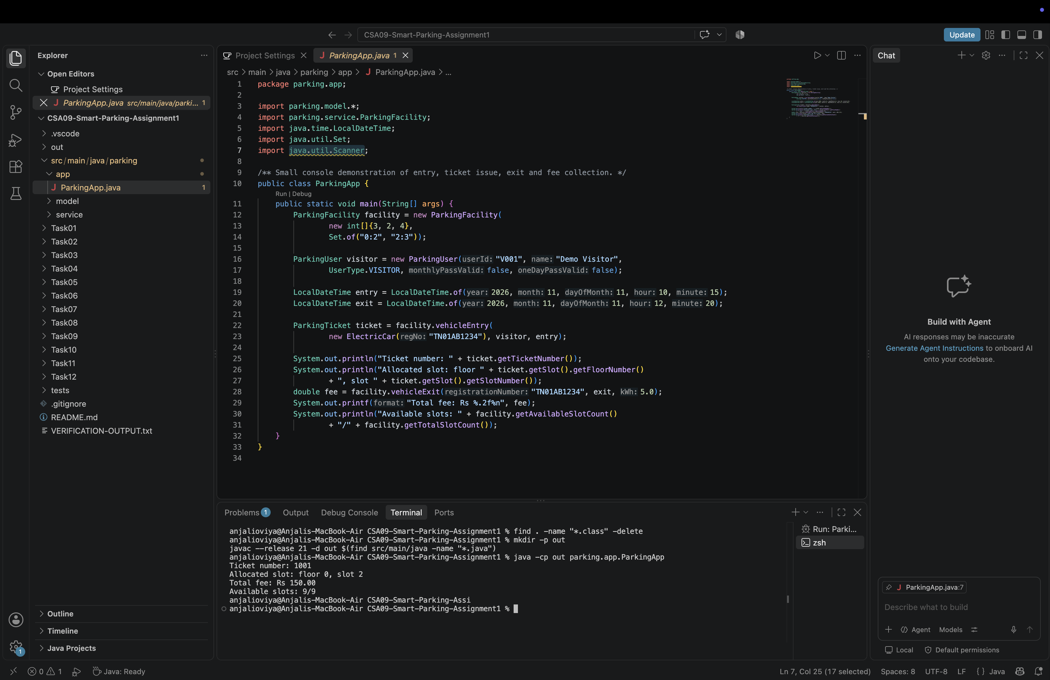
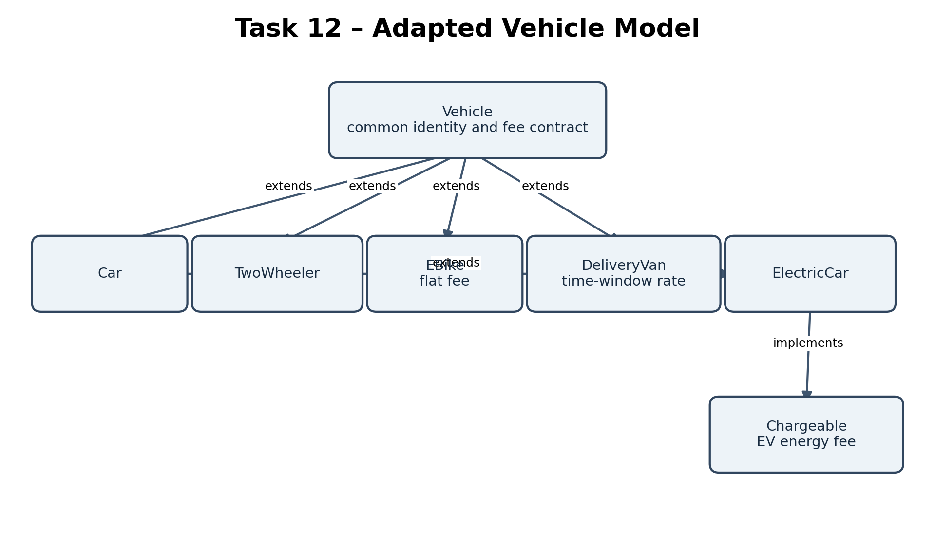
[SCREENSHOT– Task 03 allocation/release output]
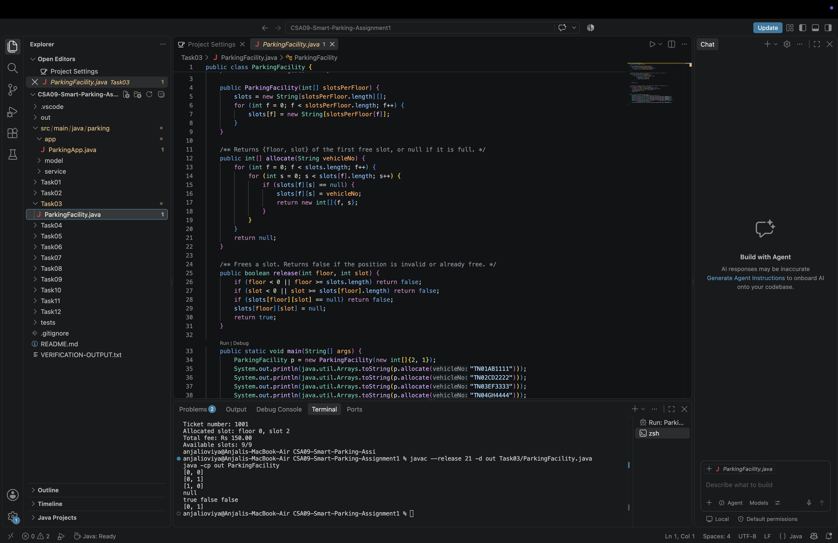
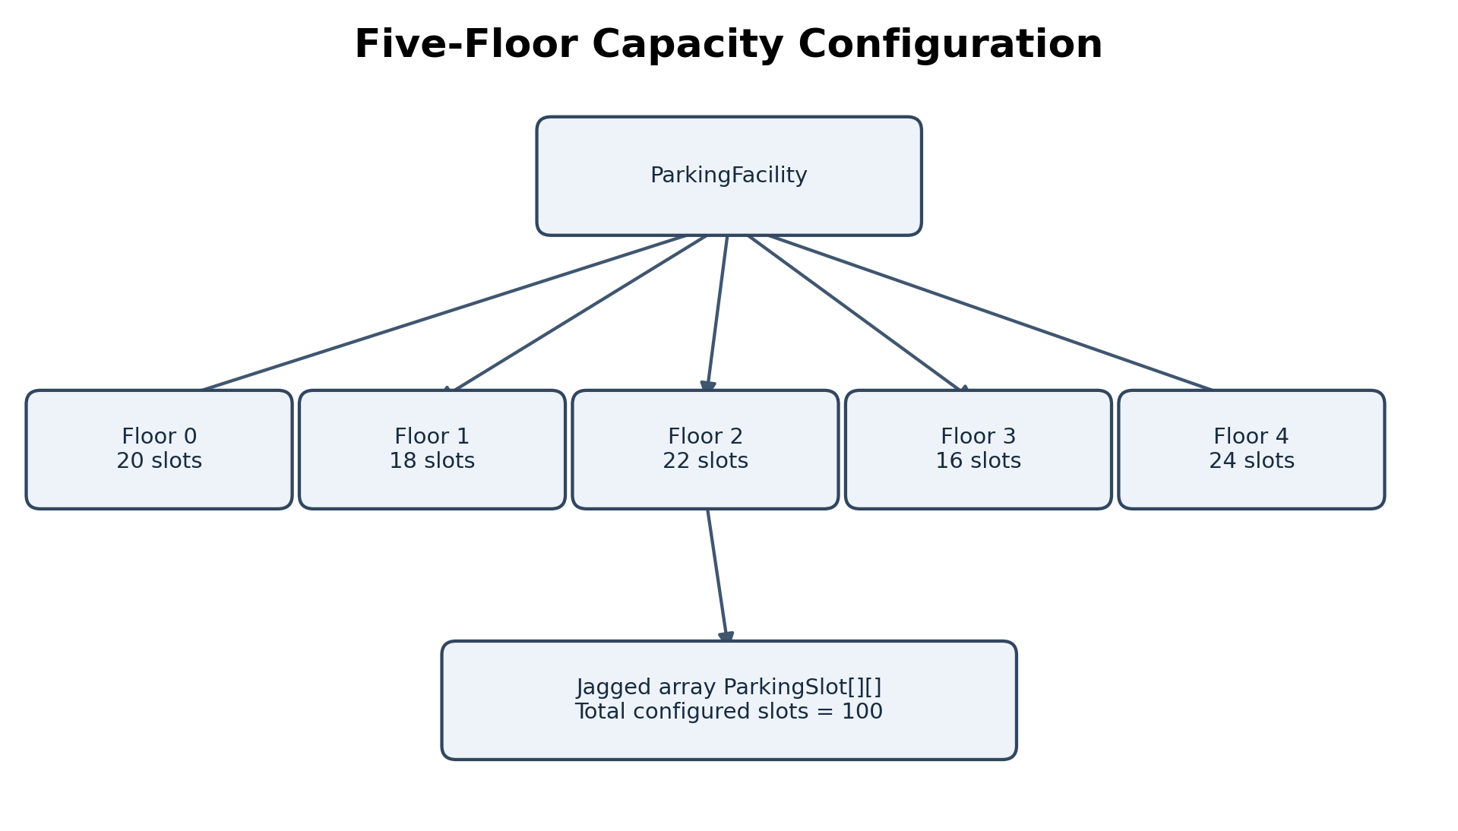
[SCREENSHOT– Task 08 FeeDemo output]
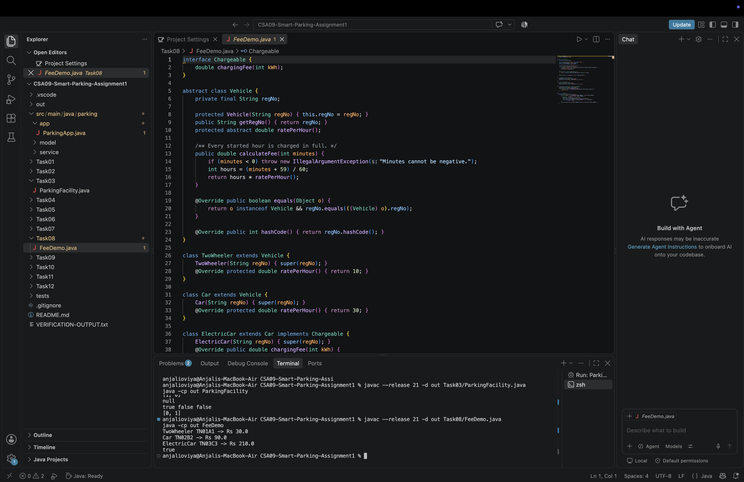
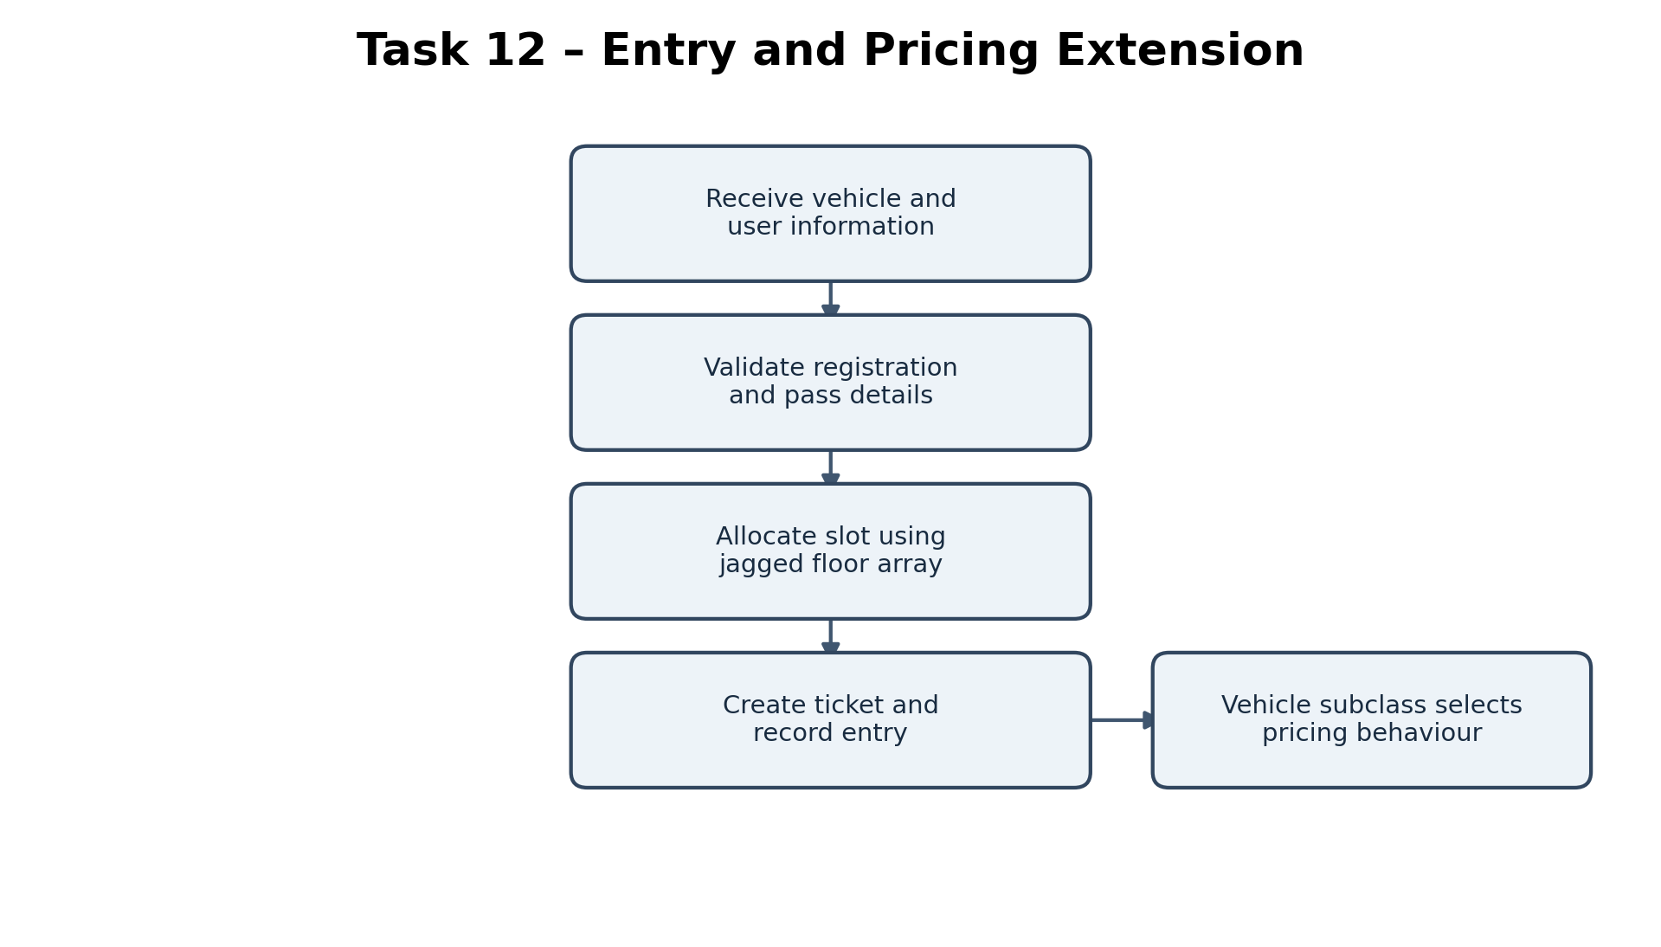

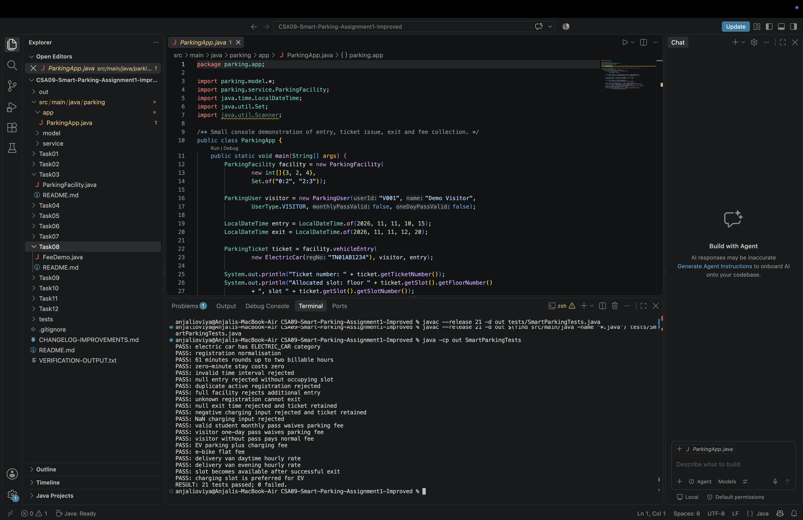
[SCREENSHOT– SmartParkingTests output showing 21 passed; 0 failed]
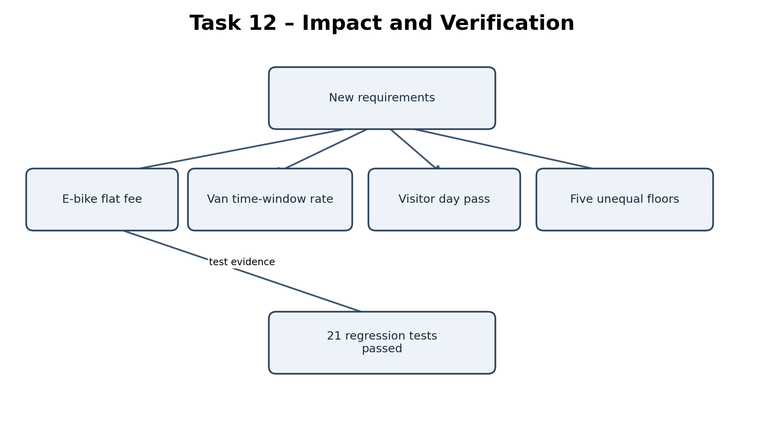
CHAPTER 13 – TASK 12 – DAY-4 DESIGN CHALLENGE
This task is worth 8 marks (2 marks each for impact analysis, evaluation, adaptation/redesign and evidence-based defence). The official changed requirements add e-bikes with a flat fee, delivery vans at double the car rate from 9 AM to 5 PM, a visitor one-day pass, and a five-floor facility with different slot counts.

13.1 A. Impact analysis
Changed requirement | Affected implementation | Assessment
E-bike flat fee | New EBike subclass; VehicleCategory.E_BIKE; flat fee constant and override. | Implemented in source; T17 tests flat Rs 20.
Delivery van day pricing | New DeliveryVan subclass and time-window fee logic. | Implemented; T18/T19 cover daytime/evening examples.
Visitor one-day pass | ParkingUser.oneDayPassValid and hasFreePass(). | Implemented; T14 verifies waiver.
Five floors with different slot counts | ParkingFacility constructor accepts int[] and creates jagged ParkingSlot[][] rows. | Variable floor counts are supported structurally, but current app only uses {3,2,4}; five-floor execution remains unverified.

A jagged array is appropriate because each floor can have a different inner-array length. To demonstrate the five-floor requirement, configure a five-element capacity array such as {20, 18, 22, 16, 24}. This is a suggested test configuration only; it is not an implemented or verified output in the supplied app.

13.2 B. Evaluation of original design
- New vehicle categories can be added as subclasses of Vehicle, overriding calculateParkingFee; ElectricCar also shows that a subclass can extend Car and implement Chargeable.
- Pricing is not fully centralized: rates and fee algorithms reside in the relevant vehicle classes, while pass-waiver and charging-fee orchestration reside in ParkingFacility.
- The original Vehicle contract and most existing classes can remain unchanged when a new independent vehicle subtype is introduced; VehicleCategory enum and any category-specific facility logic may still require changes.
- The supplied implementation's facility uses instanceof ElectricCar for charging-slot preference. If future charge-capable categories should receive the same preference, checking a capability or adding a slot-preference policy would be more extensible.

13.3 C. Adaptation or redesign
Decision: MODIFY. Retain the abstract Vehicle hierarchy, Chargeable capability, jagged slot structure and HashMap active-ticket registry. Add EBike and DeliveryVan as subclasses, add one-day pass state to ParkingUser, and keep the facility constructor parameterized by per-floor capacities. This is a targeted modification rather than a complete redesign.
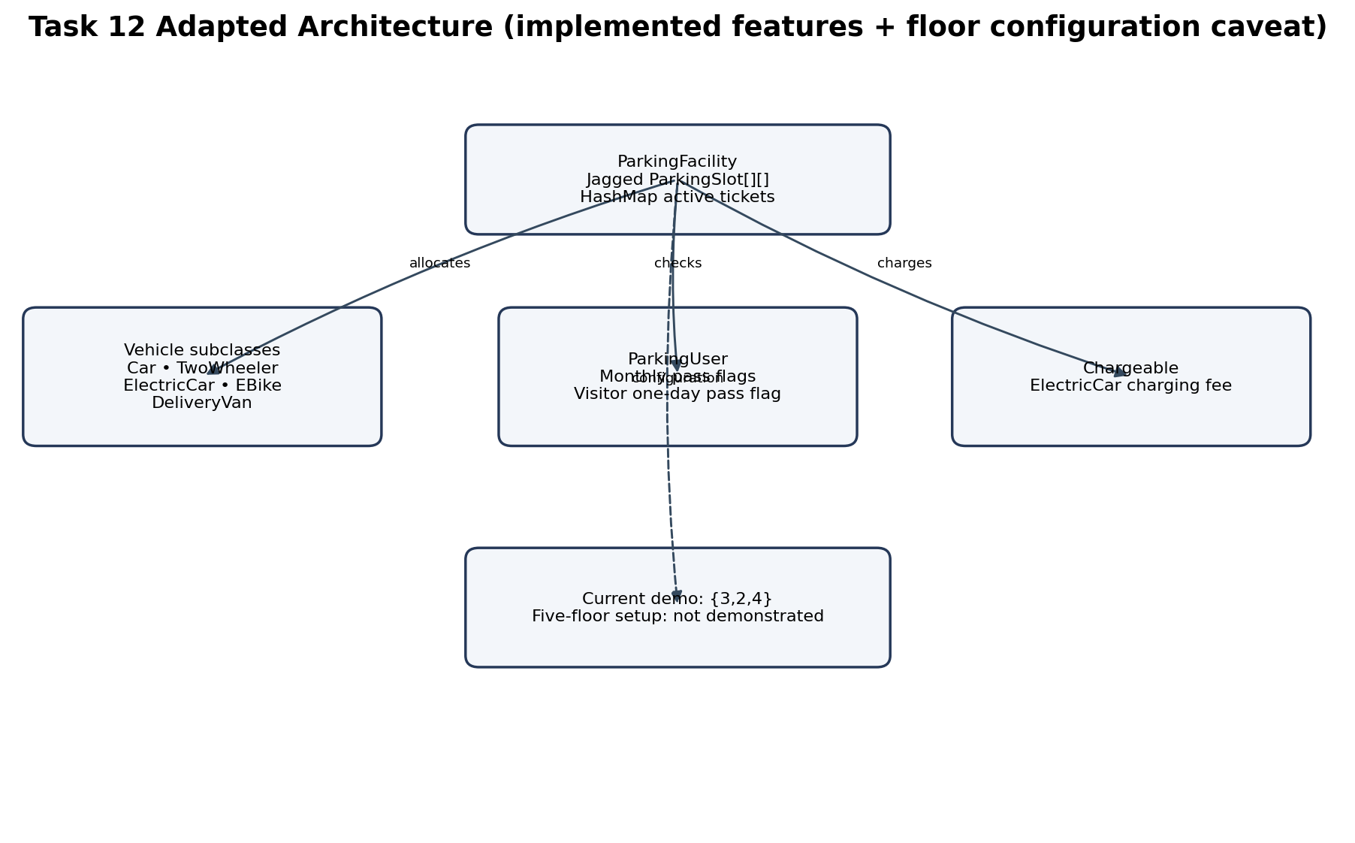
Figure 7. Task 12 architecture. The current three-floor demonstration is explicitly distinguished from the suggested five-floor configuration.

13.4 Revised class roles
- EBike extends Vehicle, identifies itself as E_BIKE and returns FLAT_FEE = Rs 20 after validating the time interval.
- DeliveryVan extends Vehicle and applies Rs 60 per billable hour for hour-start times 09:00–16:59, otherwise Rs 30.
- ParkingUser stores monthlyPassValid and oneDayPassValid; hasFreePass returns true for a valid student/staff monthly pass or a valid visitor one-day pass.
- ParkingFacility builds one ParkingSlot[] per supplied floor capacity and uses activeTickets to find current tickets.

13.5 D. Evidence-based defence
Defence point | Evidence / finding
Existing classes modified | Source comparison is not supplied as a machine-generated diff. The improved code includes the added EBike and DeliveryVan classes, E_BIKE and DELIVERY_VAN categories, pass flag logic and facility integration. Exact count of modified pre-existing files is therefore [VERIFY WITH GIT DIFF].
Ease of adding future vehicle | A new subtype can implement calculateParkingFee; if it needs charging, it can implement Chargeable. VehicleCategory may need a new enum value.
Tests for new categories | T17 verifies e-bike flat fee; T18/T19 verify delivery van day/evening rates; T14 verifies visitor pass.
Facility scale | Jagged array supports unequal per-floor capacities, but the provided main app only demonstrates three floors.
Trade-off | Subclassing keeps fee behaviour local; instanceof ElectricCar in slot selection is a coupling point that could be replaced by a slot preference capability/policy.

Final design decision: MODIFY. The existing abstraction and data structures already support most changed requirements with limited targeted extension. Do not claim that the five-floor scenario has passed until a five-element floor-capacity configuration is run and captured.

13.6 Five-floor verification action
ParkingFacility facility = new ParkingFacility(
new int[]{20, 18, 22, 16, 24},
Set.of("0:0", "2:3", "4:5")
);
// Suggested configuration only: run locally and record floor count / total slots.
After running, verify getFloorCount() returns 5 and getTotalSlotCount() returns 100 for this suggested configuration. Capture the actual terminal output; do not paste these expected values as execution evidence until verified.

CHAPTER 14 – CONCLUSION
The Campus Smart-Parking project demonstrates the main Java fundamentals and object-oriented concepts required by CO1. It analyses the domain into cohesive classes, represents floors using a jagged array, manages active tickets with a HashMap, and applies constructors, static members, inheritance, overriding, polymorphism, abstraction, interfaces, packages and encapsulation. The improved implementation includes EV charging, pass-based waivers, e-bike flat pricing, delivery-van time-window pricing and validation of several invalid inputs.
The supplied verification record documents successful runs of the main application, Task 3 and Task 8 examples, and 21 passing regression tests. Important limitations remain: the tariff values are sample assumptions, the current demonstration configures three floors rather than five, genuine screenshots must be captured by the student, and the GitHub repository link and progressive commit evidence must be supplied. A future version could add persistent storage, a graphical interface, BigDecimal-based money handling, a configurable pricing strategy, a formal test framework and concurrency control across multiple application instances.

REFERENCES
1. CSA09 Assignment 1, “Design, Implement and Validate an Object-Oriented Model for a Campus Smart-Parking System,” supplied course assignment brief, 12 pages.
2. Oracle. Java Platform, Standard Edition Documentation. https://docs.oracle.com/en/java/javase/21/ (accessed for general Java API reference; verify any specific API details before final submission).
3. Oracle. Java Language Specification, Java SE 21. https://docs.oracle.com/javase/specs/jls/se21/html/ (language semantics reference).
4. Supplied project archive: CSA09-Smart-Parking-Assignment1-Improved, including README.md, source files, Task03/ParkingFacility.java, Task08/FeeDemo.java, SmartParkingTests.java and VERIFICATION-OUTPUT.txt.
5. Java API documentation: AtomicLong, LocalDateTime, Duration, HashMap and Scanner, Java SE 21 API documentation at https://docs.oracle.com/en/java/javase/21/docs/api/.

APPENDIX A – REPOSITORY AND SUBMISSION CHECKLIST
- [ ] Create/share GitHub repository named CSA09-192521452-Assignment1.
- [ ] Add this report's repository URL to the cover page.
- [ ] Ensure Task01–Task12 folders contain required source, README and genuine output evidence.
- [ ] Make progressive commits, at least one per task, as required by the assignment brief.
- [ ] Run Main ParkingApp.java, Task03/ParkingFacility.java, Task08/FeeDemo.java and SmartParkingTests.java on your Mac.
- [ ] Capture genuine screenshots for all four outputs and insert them at the marked locations.
- [ ] Run a five-floor configuration and record actual getFloorCount()/getTotalSlotCount() evidence.
- [ ] Update the Word table of contents and page fields before submission.
- [ ] Complete institution, department, faculty, date and declaration/acknowledgement details.

APPENDIX C – UML AND FLOWCHART DIAGRAMS
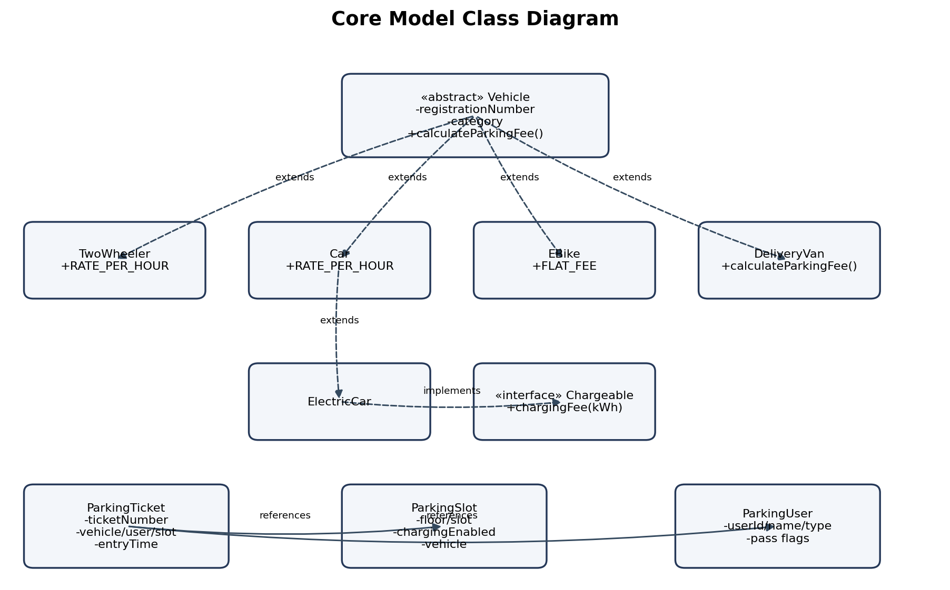
Figure 2. Core model class diagram. Relationship arrows show subclassing and capability implementation; ticket references are associations.
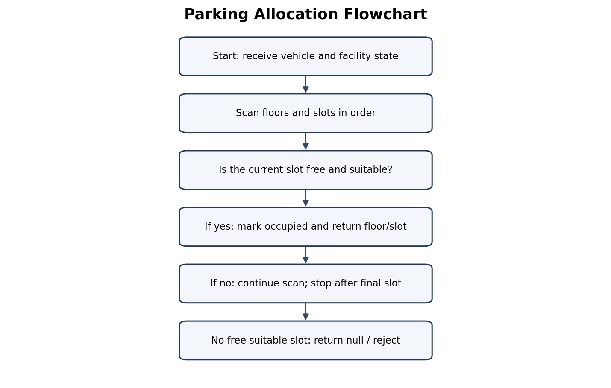
Figure 8. Parking allocation flowchart.
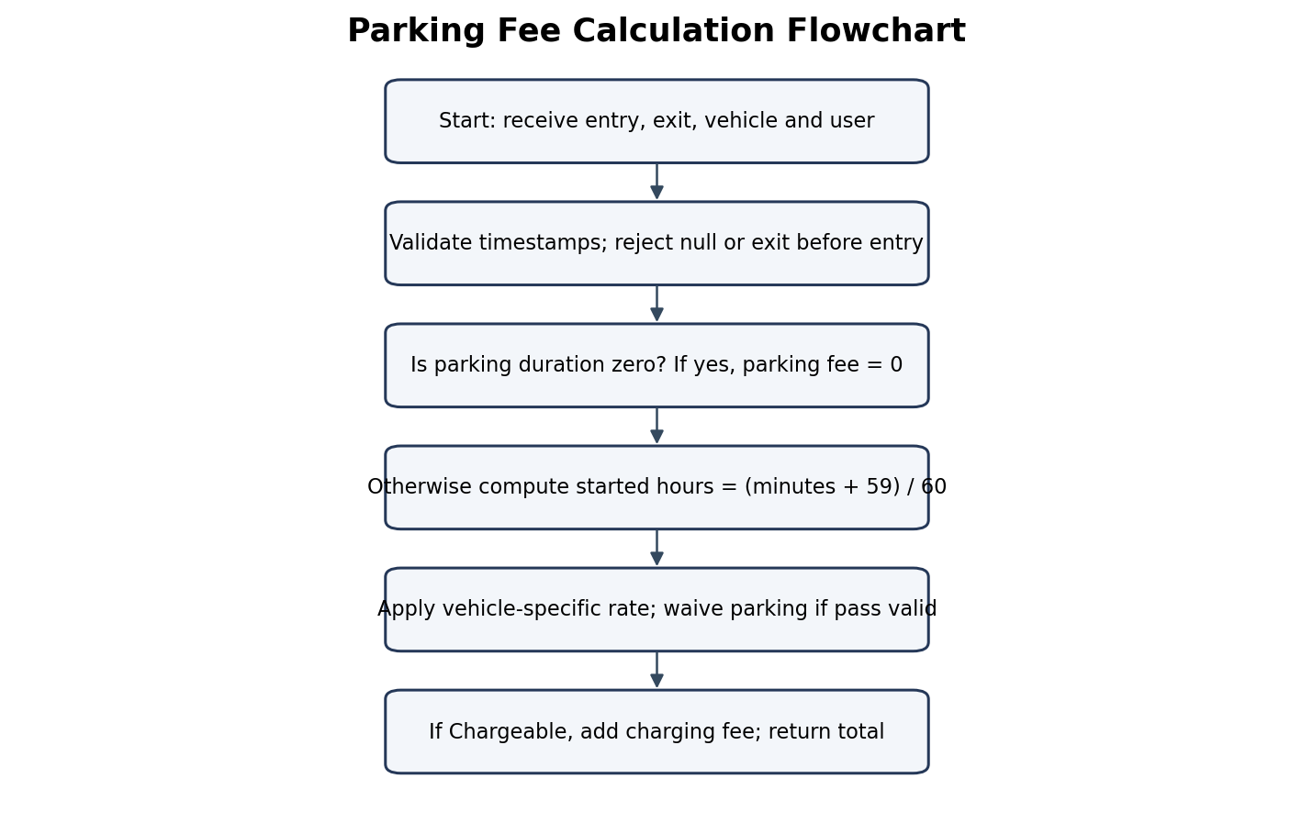
Figure 9. Parking fee calculation flowchart.

